**USER SIGNUP TESTING (CLIENT/TRAINER)**

Contents

Empty values provided 2

Phone number is not the right length according to country and password validation not matched 3

Password validation still not matched 4

Trying to sign up with credentials that are already in use 5

Valid credentials provided; user brought to OTP verification page 6

Automatic captcha checking 7

OTP received in messages 8

Entered the OTP code that was received 9

Proof that user was added to Firebase 10

# Empty values provided

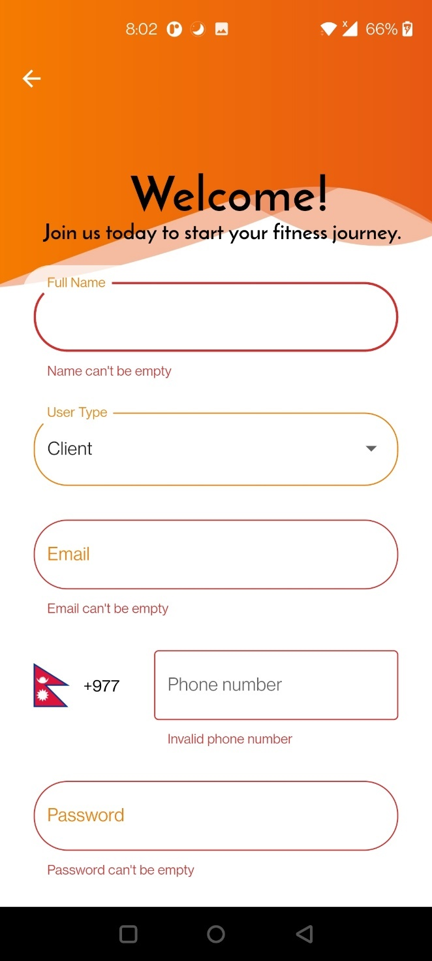

# Phone number is not the right length according to country and password validation not matched

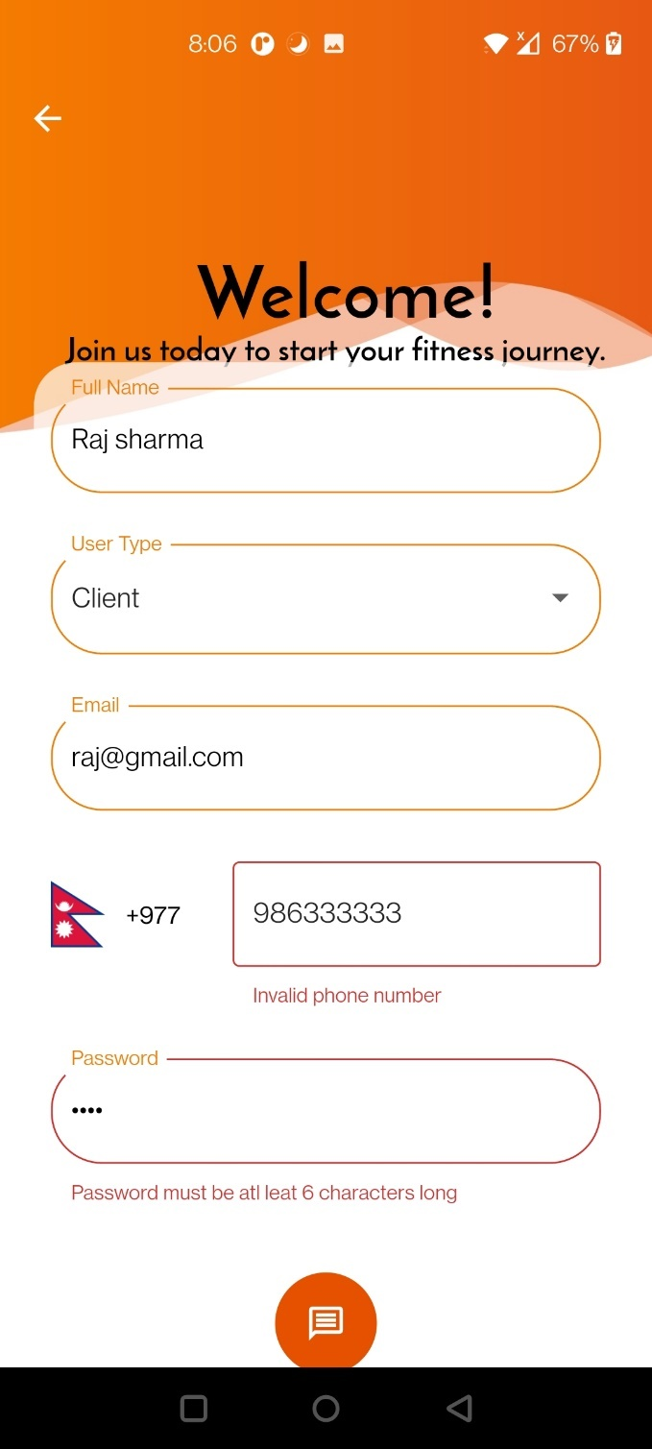

# Password validation still not matched

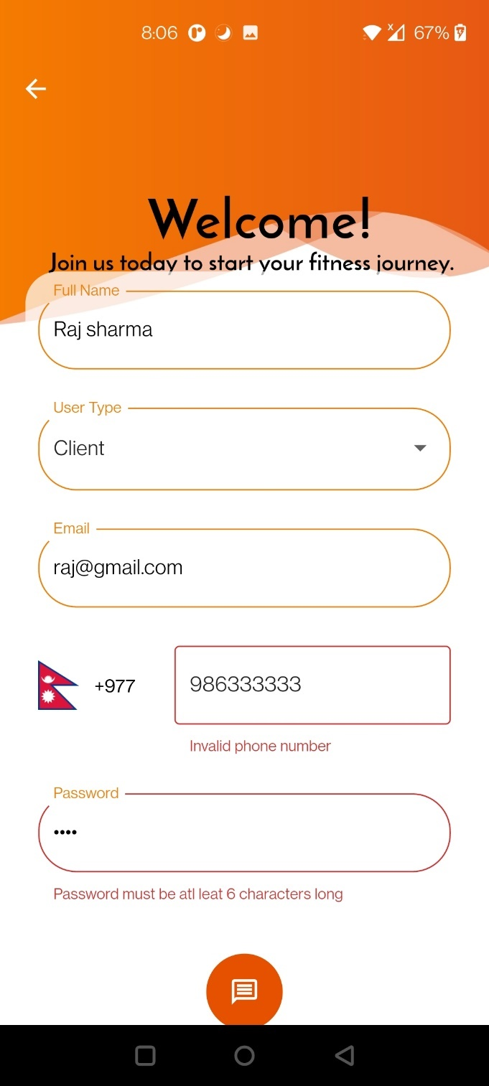

# Trying to sign up with credentials that are already in use

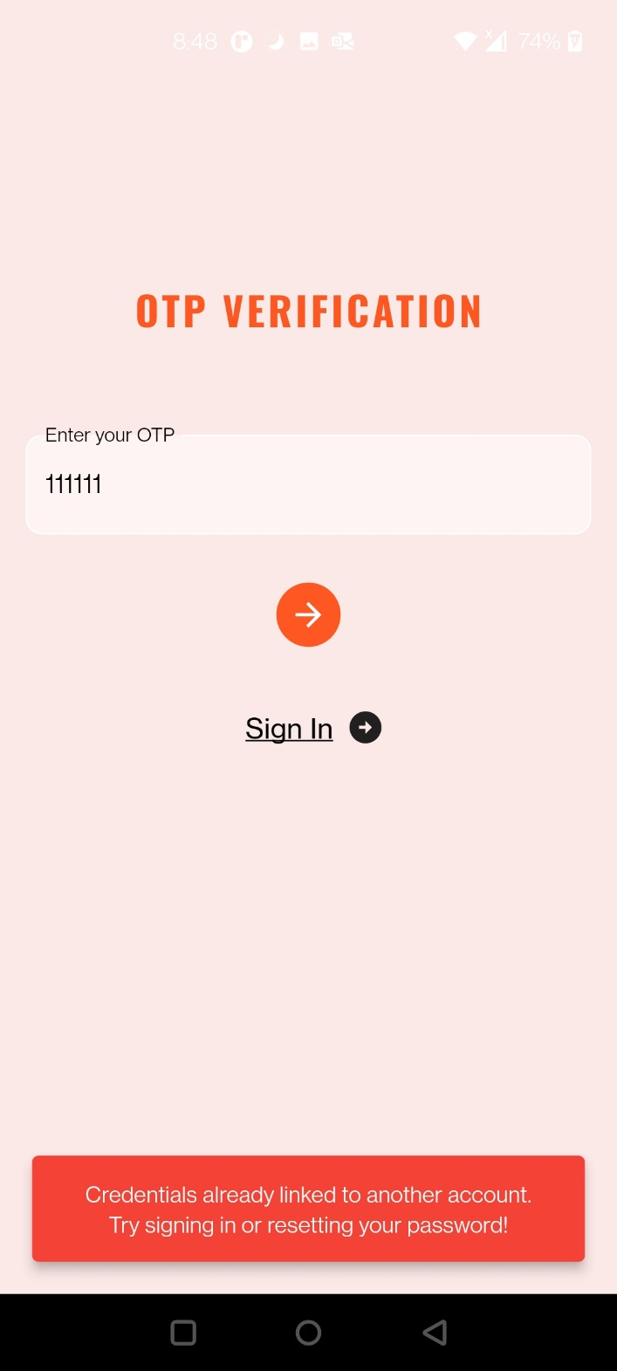

# Valid credentials provided; user brought to OTP verification page

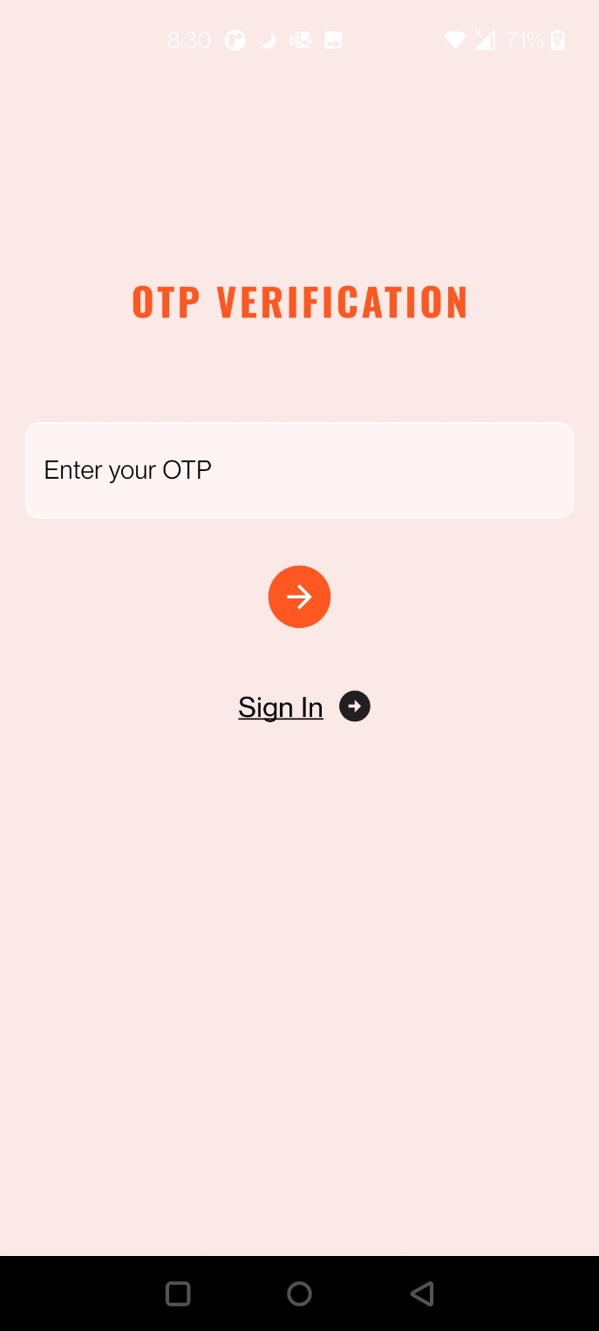

# Automatic captcha checking

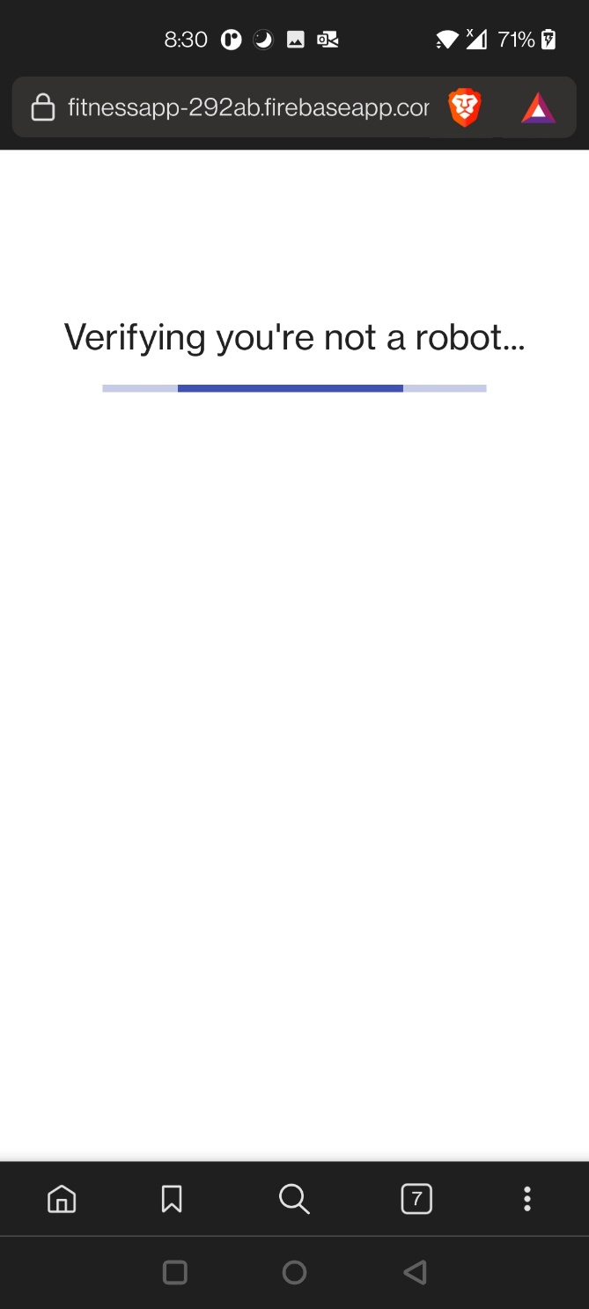

# OTP received in messages

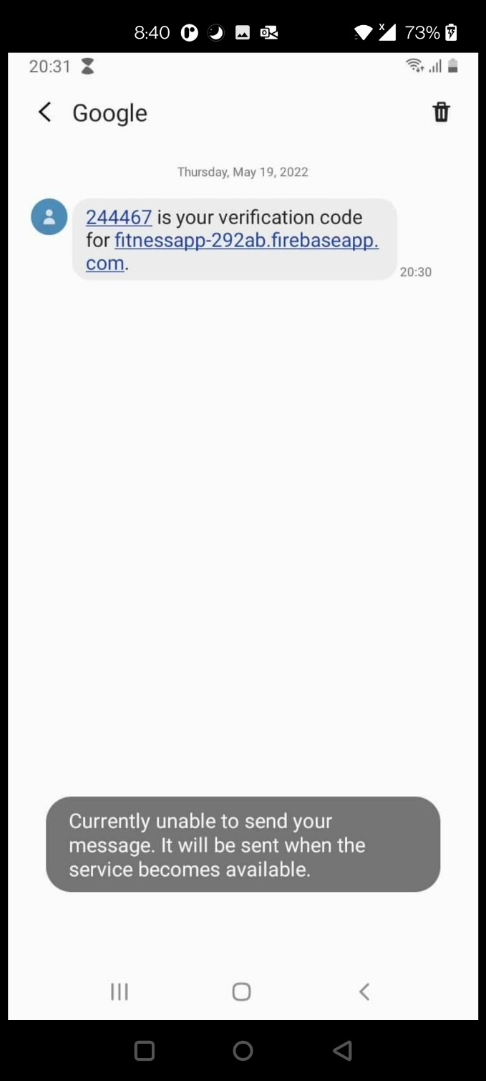

# Entered the OTP code that was received

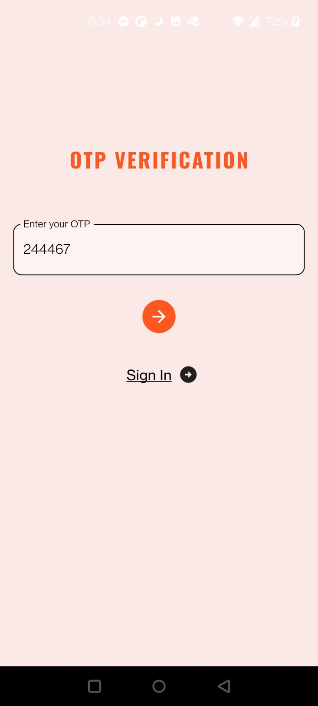

# Proof that user was added to Firebase

